LABORATORY05: Report and Presentation of work on Tables

PELE TETE

December 2025

# 1ManipulatingThespaceBetweenColumns - Column Spacing

\documentclass{article}  
\usepackage[T1]{fontenc}  
\usepackage{array}  
\setlength\tabcolsep{1cm}  
  
\begin{document}  
\section{Introduction to space between columns}  
This space is defined with the length \verb|\tabcolsep|. Due  
to the fact that each column is padded on both sides you get one \verb|\tabcolsep|  
on either end of the table, and 2 \verb|\tabcolsep| between two columns one from each  
column. We can adjust this space to any length using \verb|\setlength|.  
  
\begin{tabular}{lll}  
 Animal & Food & Size \\  
 dog & meat & medium \\  
 horse & hay & large \\  
 frog & flies & small \\  
\end{tabular}  
\end{document}

## Generated figure

Table with increased column spacing (1cm).

## Screenshot

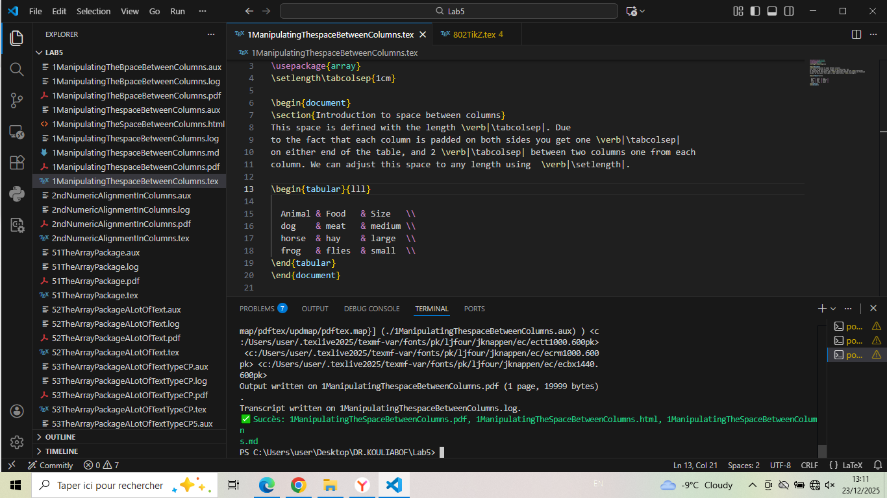

# 2ndNumericAlignmentInColumns - Numeric Alignment

\documentclass{article}  
\usepackage[T1]{fontenc}  
\usepackage{booktabs}  
\usepackage{siunitx}  
\begin{document}  
  
\section{Commentary and Interpretation}  
Here I just try one eg in: package documentation Page 5,  
 Titre: 3.1 Numbers  
  
\begin{tabular}{SS}  
\toprule  
{Values} & {More Values} \\  
\midrule  
123 & \num{123} \\  
1234 & \num{1234} \\  
12345 & \num{12345} \\  
0.123 & \num{0.123} \\  
0,1234 & \num{0,1234} \\  
0.12345 & \num{.12345} \\  
\bottomrule  
\end{tabular}  
\end{document}

## Generated figure

Numeric alignment with siunitx package.

## Screenshot

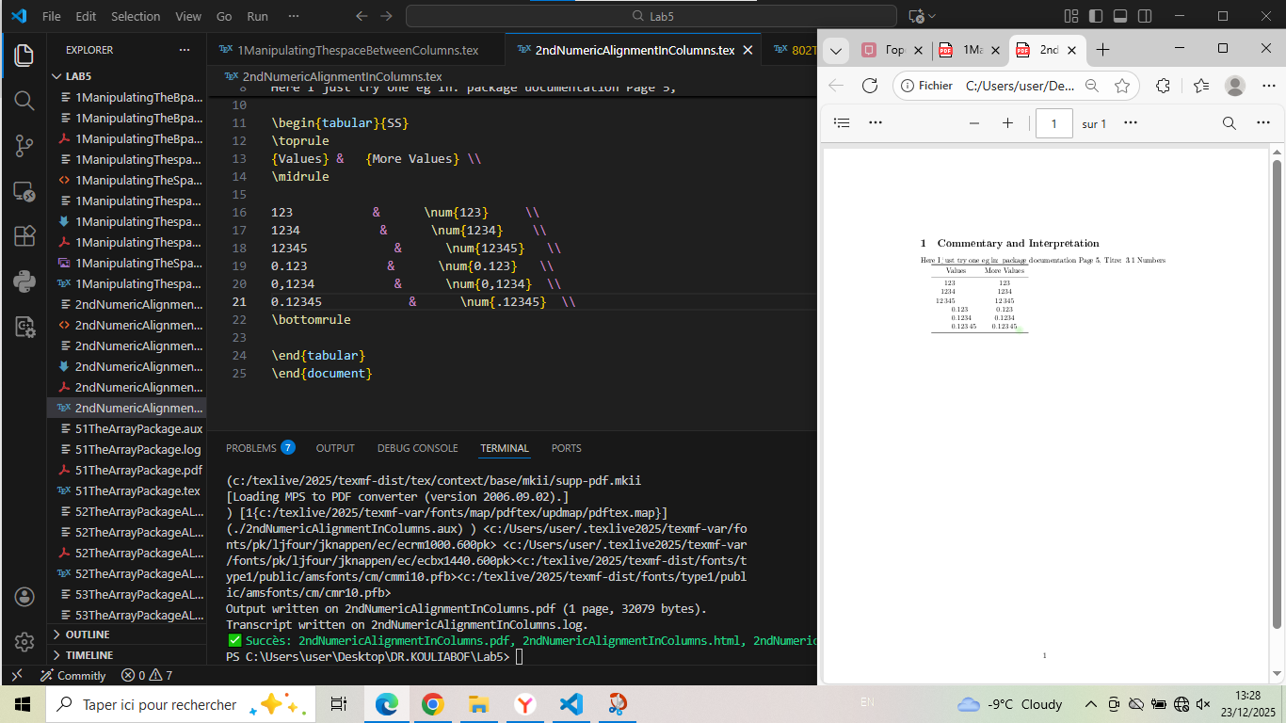

# 51TheArrayPackage - Basic Array Usage

\documentclass{article}  
\usepackage[T1]{fontenc}  
\usepackage{array}  
\begin{document}  
\section{Array}  
\begin{tabular}{lll}  
 Animal & Food & Size \\  
 dog & meat & medium \\  
 horse & hay & large \\  
 frog & flies & small \\  
\end{tabular}  
  
\section{My intepretation}  
~We can see three (03) Columns (Animals, Foods and Size) because of using Array Package: {array}  
  
~To succed this compillation we have to use at the begin (111 = '3' the number of the Column){tabular}   
but at the end we have To use {tabular}.  
\end{document}

## Generated figure

Basic table with three columns.

## Screenshot

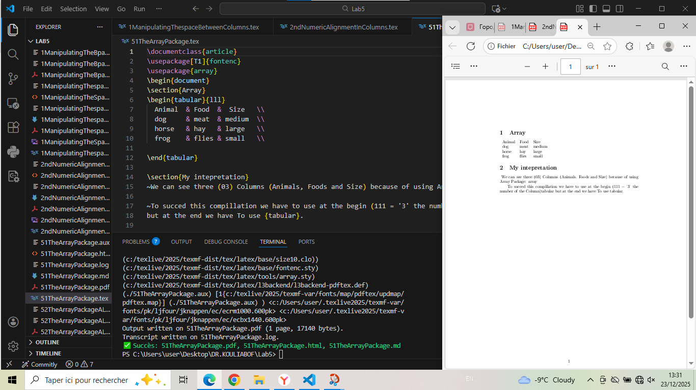

# 52TheArrayPackageALotOfText - Long Text in Columns

\documentclass{article}  
\usepackage[T1]{fontenc}  
\usepackage{array}  
  
\begin{document}  
  
\section{Trying the type l.}  
  
We will see 2 Columns (c=Animal and l=left aligned column=Description) because of the use of: {tabular}{cl}  
\section{Array:2}  
\begin{tabular}{cl}  
 Animal & Description \\  
 dog & The dog is a member of the genus Canis,which forms part of the  
 wolf-like canids, and is the most widely abundant terrestrial carnivore. \\  
cat & The cat is a domestic species of small carnivorous mammal. It is the   
 only domesticated species in the family Felidae and is often referred   
 to as the domestic cat to distinguish it from the wild members of the  
 family. \\  
\end{tabular}  
  
\section{My intepretation}  
Here the issue is that the l type column typesets its contents in a single row at its natural  
width, even if there is a page border in the way.But we can correcte it.  
\end{document}

## Generated figure

Table with long text in left-aligned column.

## Screenshot

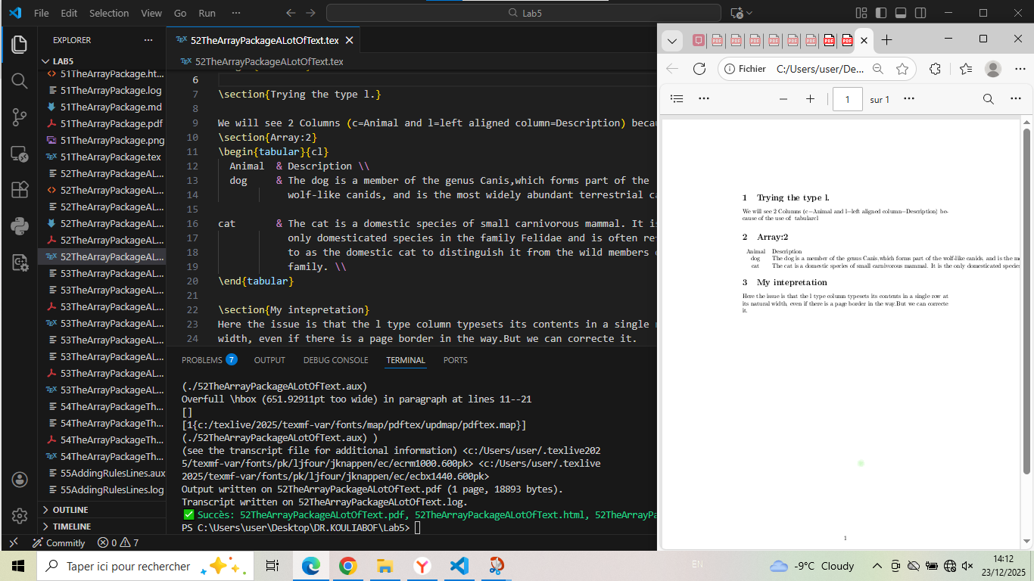

# 53TheArrayPackageALotOfTextTypeCP - Paragraph Columns (9cm)

\documentclass{article}  
\usepackage[T1]{fontenc}  
\usepackage{array}  
  
\begin{document}  
  
\section{Trying the type cp: {9cm.}}  
  
We will see 2 Columns (c=Animal and p=column fully justified=Description) because of the use of: {tabular}{cp}  
\section{Array:2}  
\begin{tabular}{cp{9cm}} % We are going to use "cp" to justifie the text  
 Animal & Description \\  
 dog & The dog is a member of the genus Canis, which forms  
 part of the  
 wolf-like canids, and is the most widely abundant  
 terrestrial  
 carnivore. \\  
 cat & The cat is a domestic species of small carnivorous  
 mammal. It is the  
 only domesticated species in the family Felidae and  
 is often referred  
 to as the domestic cat to distinguish it from the  
 wild members of the  
 family. \\  
\end{tabular}  
  
\section{My intepretation}  
Here the text will be  
automatically line wrapped and fully justified  
m{9cm} like p, but vertically centered compared to the rest of the  
row.  
will try for 5cm and see in the next file.  
\end{document}

## Generated figure

Table with paragraph column (9cm width).

## Screenshot

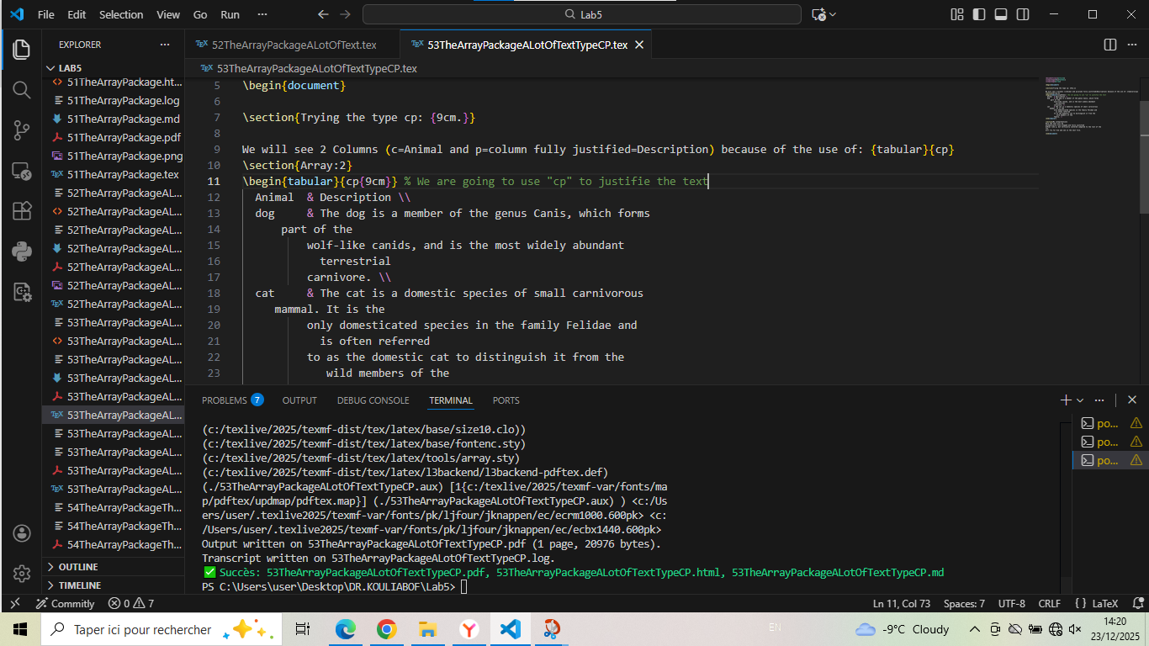

# 53TheArrayPackageALotOfTextTypeCP5 - Paragraph Columns (5cm)

\documentclass{article}  
\usepackage[T1]{fontenc}  
\usepackage{array}  
  
\begin{document}  
  
\section{Trying the type cp: {5cm.}}  
  
We will see 2 Columns (c=Animal and p=column fully justified=Description) because of the use of: {tabular}{cp}  
\section{Array:2}  
\begin{tabular}{cp{5cm}} % My own Eg to make justification between 5cm  
 Animal & Description \\  
 dog & The dog is a member of the genus Canis, which forms  
 part of the  
 wolf-like canids, and is the most widely abundant  
 terrestrial  
 carnivore. \\  
 cat & The cat is a domestic species of small carnivorous  
 mammal. It is the  
 only domesticated species in the family Felidae and  
 is often referred  
 to as the domestic cat to distinguish it from the  
 wild members of the  
 family. \\  
\end{tabular}  
  
\section{My intepretation}  
Here the text will be  
automatically line wrapped and fully justified  
m{5cm} like p, but vertically centered compared to the rest of the  
row.  
Here We can see for 5cm.  
\end{document}

## Generated figure

Table with narrower paragraph column (5cm width).

## Screenshot

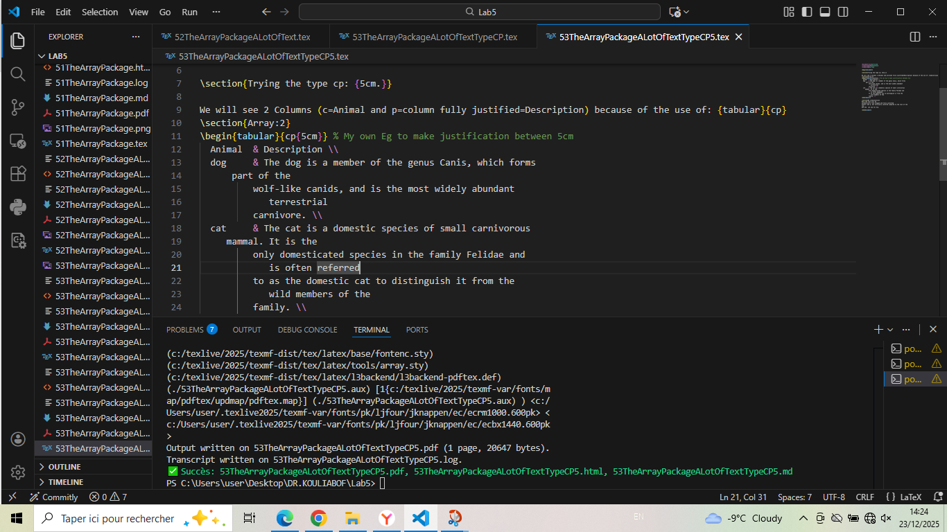

# 54TheArrayPackageTheSameType - Multiple Same Type Columns

\documentclass{article}  
\usepackage[T1]{fontenc}  
\usepackage{array}  
  
\begin{document}  
  
\section{Trying the type cp:{6}{c} the same type}  
  
We will see 2 Columns: c=Animal and p=column fully justified=Description,  
because of the use of: \verb|{tabular}{6}{c}| same type.  
\section{Array:2}  
\begin{tabular}{6}{c}   
 Animal & Description \\  
 dog & The dog is a member of the genus Canis, which forms  
 part of the  
 wolf-like canids, and is the most widely abundant  
 terrestrial  
 carnivore. \\  
 cat & The cat is a domestic species of small carnivorous  
 mammal. It is the  
 only domesticated species in the family Felidae and  
 is often referred  
 to as the domestic cat to distinguish it from the  
 wild members of the  
 family. \\  
\end{tabular}  
  
\section{My intepretation}  
Here the text will be  
automatically line wrapped and fully justified  
m{6cm} like p, but vertically centered compared to the rest of the  
row.And at the end the number of table has many columns of the same type.  
Here We can see for {6}{c}cm.  
\end{document}

## Generated figure

Table with multiple same-type columns (error demonstration).

## Screenshot

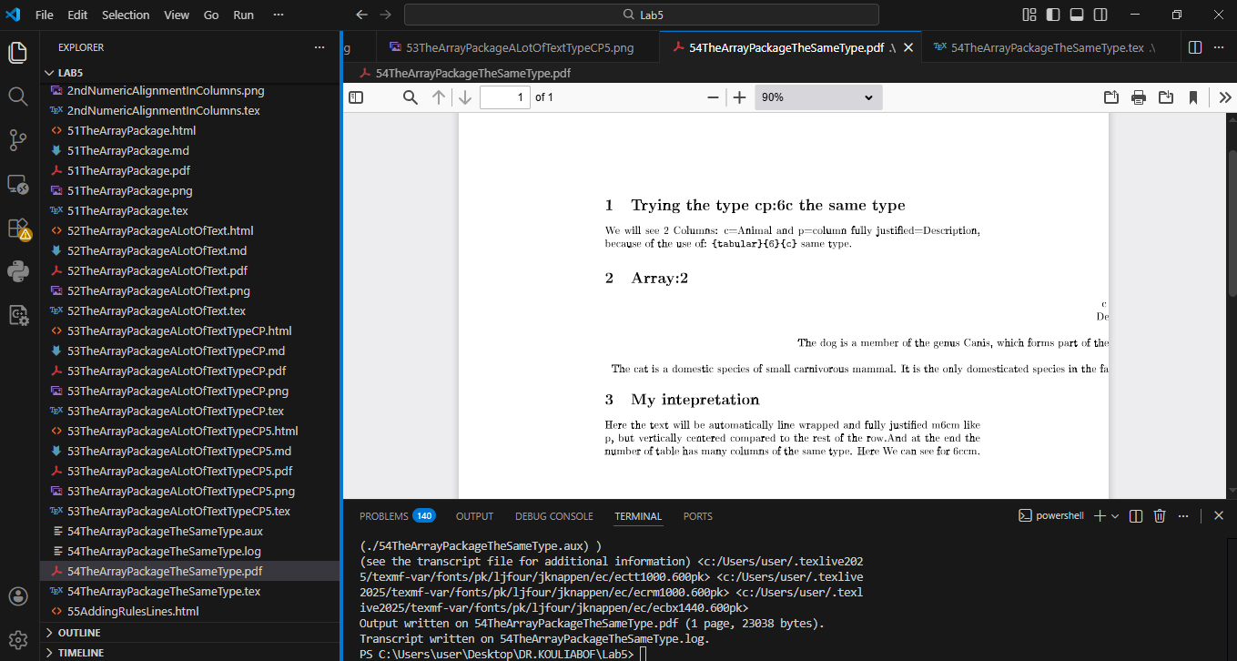

# 541TheArrayPackageEquivalC - Using *ntype Syntax

\documentclass{article}  
\usepackage[T1]{fontenc}  
\usepackage{array}  
\begin{document}  
  
\begin{tabular}{*{3}{l}}  
 Animal & Food & Size \\  
 dog & meat & medium \\  
 horse & hay & large \\  
 frog & flies & small \\  
\end{tabular}  
\end{document}

## Generated figure

Table with *3l syntax for three left-aligned columns.

## Screenshot

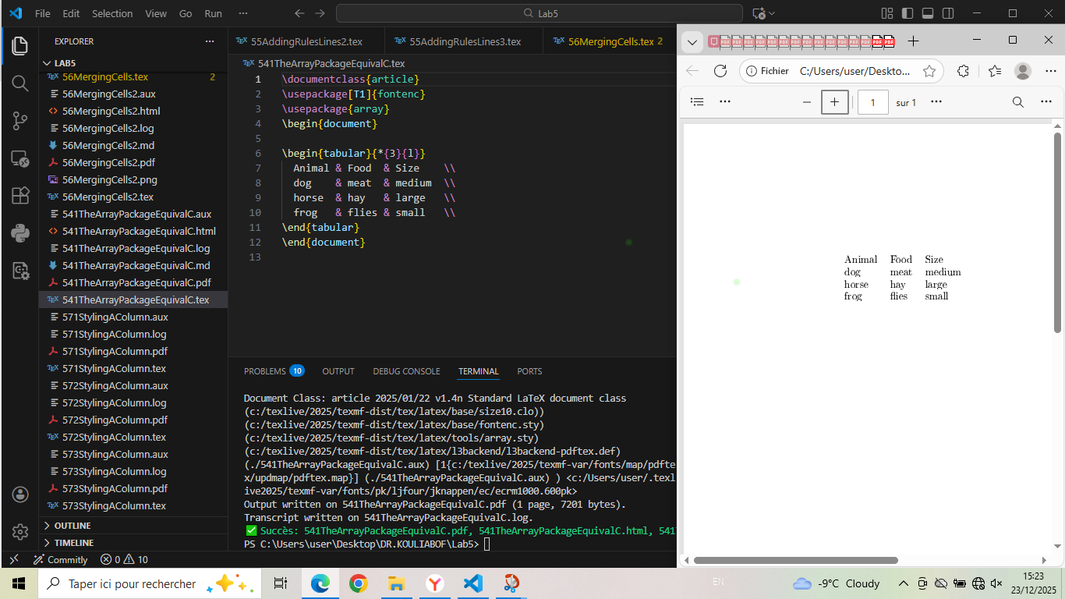

# 55AddingRulesLines - Basic Table Rules

\documentclass{article}  
\usepackage[T1]{fontenc}  
\usepackage{array}  
\usepackage{booktabs}  
  
\begin{document}  
  
\section{Different types of lines:toprule, midrule, and bottomrule}  
  
\begin{tabular}{lll}  
 \toprule  
 Animal & Food & Size \\  
 \midrule  
 dog & meat & medium \\  
 horse & hay & large \\  
 frog & flies & small \\   
 \bottomrule  
\end{tabular}  
  
section{My commentary:}  
The use of these keys(toprule, midrule, and bottomrule) gives us the possibility to get   
\end{document}

## Generated figure

Table with booktabs rules (toprule, midrule, bottomrule).

## Screenshot

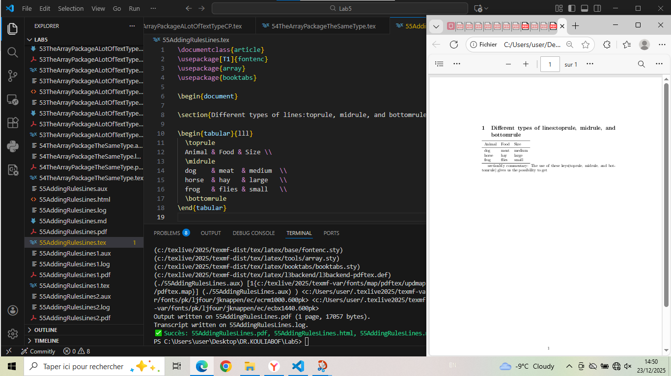

# 55AddingRulesLines1 - cmidrule Usage

\documentclass{article}  
\usepackage[T1]{fontenc}  
\usepackage{array}  
\usepackage{booktabs}  
  
\begin{document}  
The fourth rule command provided by booktabs is \verb|\cmidrule|. It can be used  
to draw a rule that doesn't span the entire width of the table but only a specified  
column range. A column range is entered as a number span: {number-number}.  
\begin{tabular}{lll}  
 \toprule  
 Animal & Food & Size \\  
 \midrule  
 dog & meat & medium \\  
 \cmidrule{1-2}  
 horse & hay & large \\  
 \cmidrule{1-1}  
 \cmidrule{3-3}  
 frog & flies & small \\  
 \bottomrule  
\end{tabular}  
\end{document}

## Generated figure

Table with partial rules using cmidrule.

## Screenshot

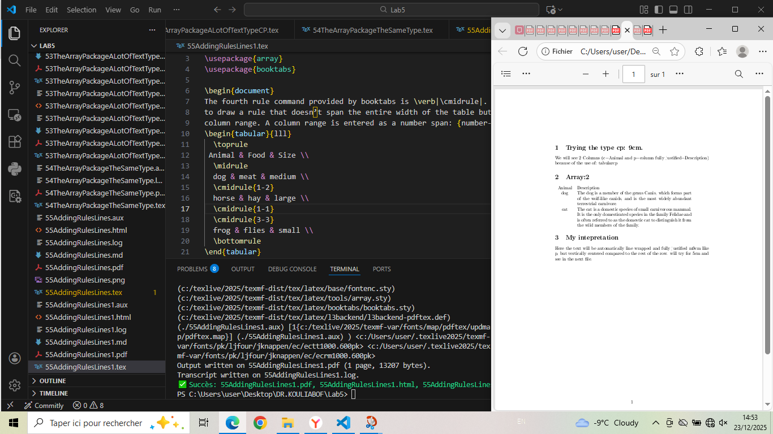

# 55AddingRulesLines2 - cmidrule with Trimming

\documentclass{article}  
\usepackage[T1]{fontenc}  
\usepackage{array}  
\usepackage{booktabs}  
  
\begin{document}  
  
There is another useful feature of \verb|\cmidrule|.  
We can shorten it on either end  
with an optional argument enclosed in parentheses:  
 \begin{tabular}{lll}  
 \toprule  
 Animal & Food & Size \\  
 \midrule  
 dog & meat & medium \\  
 \cmidrule{1-2}  
 horse & hay & large \\   
 \cmidrule(r){1-1}  
 \cmidrule(rl){2-2}  
 \cmidrule(l){3-3}  
 frog & flies & small \\  
 \bottomrule  
\end{tabular}  
We may have guessed that r and l mean the rule is shortened on its right and left  
end, respectively  
\end{document}

## Generated figure

Table with trimmed cmidrule rules.

## Screenshot

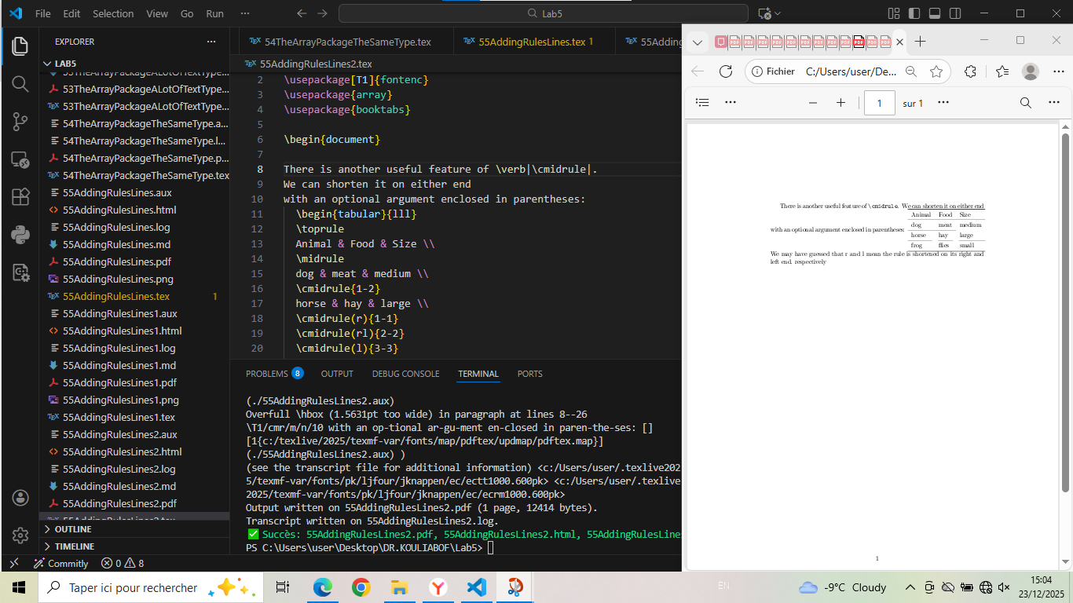

# 55AddingRulesLines3 - addlinespace Usage

\documentclass{article}  
\usepackage[T1]{fontenc}  
\usepackage{array}  
\usepackage{booktabs}  
  
\begin{document}  
  
\section{The meaning of booktabs:Rules Lines.}  
Sometimes a rule would be too much of a separation for two rows but to get across  
the meaning more clearly you want to separate them by some means. In this case  
we can use \\addlinespace to insert a small skip.  
\section{Animal and Description with the rules:}  
  
\begin{tabular}{cp{9cm}}  
 \toprule  
 Animal & Description \\  
 \midrule  
 dog & The dog is a member of the genus Canis, which forms part of the  
 wolf-like canids, and is the most widely abundant terrestrial carnivore. \\  
 \addlinespace  
 cat & The cat is a domestic species of small carnivorous mammal. It is the  
 only domesticated species in the family Felidae and  
 is often referred  
 to as the domestic cat to distinguish it from the  
 wild members of the  
 family. \\  
 \bottomrule  
\end{tabular}  
\end{document}

## Generated figure

Table with vertical spacing using addlinespace.

## Screenshot

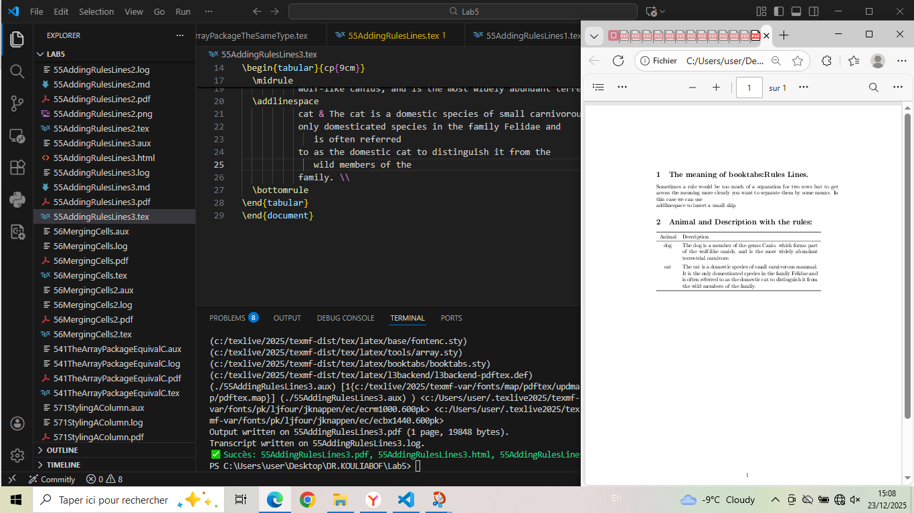

# 56MergingCells - Horizontal Cell Merging

\documentclass{article}  
\usepackage{array, booktabs}  
  
\begin{document}  
  
\begin{tabular}{lcc}  
\toprule  
\multicolumn{1}{c}{Animal} & Taille & Poids \\  
\midrule  
Chien & Moyen & 15 kg \\  
Chat & Petit & 5 kg \\  
Éléphant & Grand & 5000 kg \\  
\bottomrule  
\end{tabular}  
  
\bigskip  
  
% Tableau avec fusion horizontale  
\begin{tabular}{|l|c|c|}  
\hline  
\multicolumn{3}{|c|}{Informations} \\  
\hline  
Nom & Âge & Ville \\  
\hline  
Alice & 25 & Paris \\  
Bob & 30 & Londres \\  
\hline  
\end{tabular}  
  
\end{document}

## Generated figure

Tables with horizontally merged cells using multicolumn.

## Screenshot

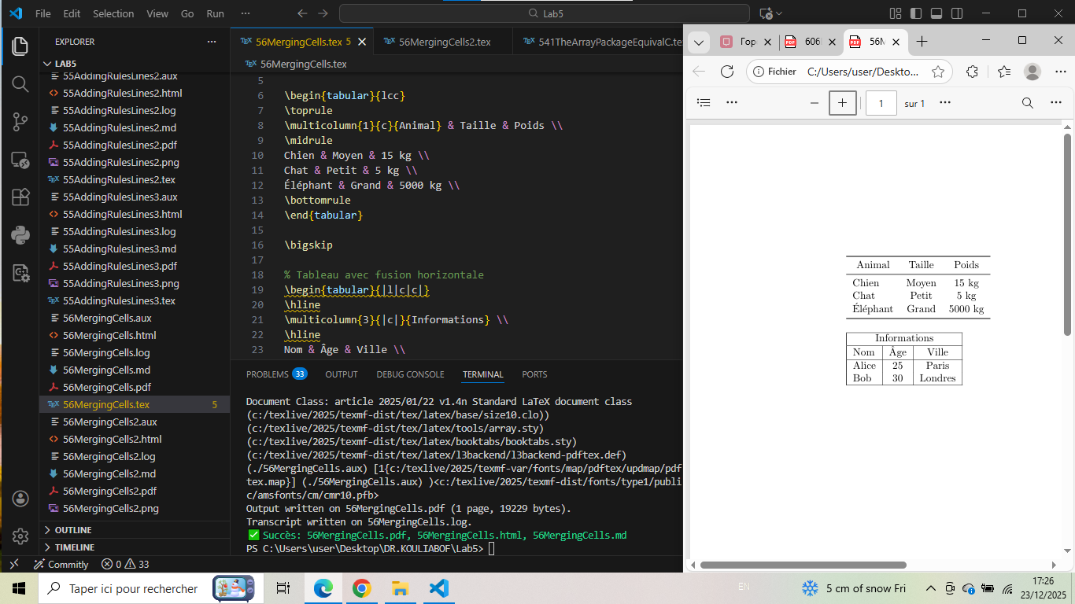

# 56MergingCells2 - Vertical Merging Simulation

\documentclass{article}  
\usepackage[T1]{fontenc}  
\usepackage{array}  
\usepackage{booktabs}  
  
\begin{document}  
\section{Explication}  
Merging cells vertically isn't supported by LaTeX. Usually it suffices to leave cells  
empty to give the reader the correct idea of what was meant without explicitly  
making cells span rows.  
  
\begin{tabular}{lll}  
 \toprule  
 Group & Animal & Size \\  
 \midrule  
 herbivore & horse & large \\  
 & deer & medium \\  
 & rabbit & small \\  
 \addlinespace  
 carnivore & dog & medium \\  
 & cat & small \\  
 & lion & large \\  
 \addlinespace  
 omnivore & crow & small \\  
 & bear & large \\  
 & pig & medium \\  
 \bottomrule  
 \end{tabular}  
\end{document}

## Generated figure

Table simulating vertical merging with empty cells.

## Screenshot

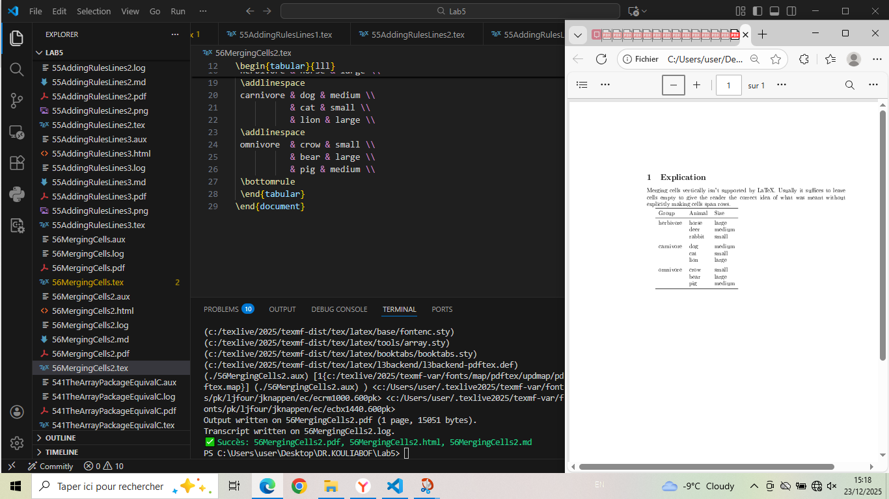

# 571StylingAColumn - Column Styling

\documentclass{article}  
\usepackage[T1]{fontenc}  
\usepackage{array}  
\usepackage{booktabs}  
\begin{document}  
\begin{tabular}{>{\itshape}l<{:} *{2}{l}}  
 \toprule  
 Animal & Food & Size \\  
 \midrule  
 dog & meat & medium \\  
 horse & hay & large \\  
 frog & flies & small \\  
 \bottomrule  
\end{tabular}  
\end{document}

## Generated figure

Table with italic first column and colon separator.

## Screenshot

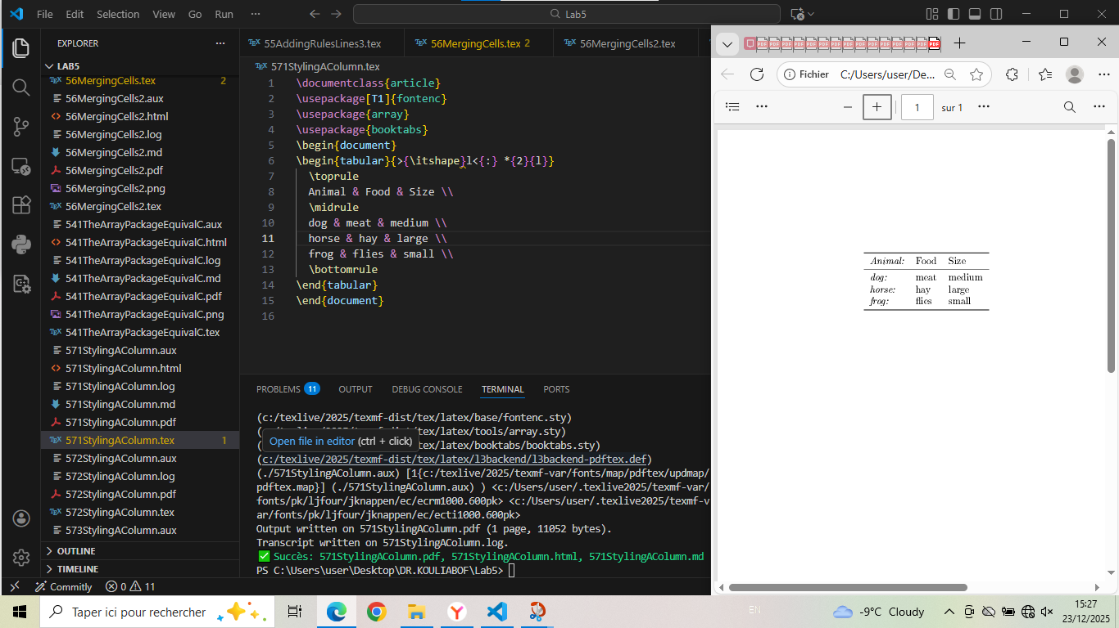

# 572StylingAColumn - Header Exclusion from Styling

\documentclass{article}  
\usepackage[T1]{fontenc}  
\usepackage{array}  
\usepackage{booktabs}  
  
\begin{document}  
\begin{tabular}{>{\itshape}l<{:} *{2}{l}}  
 \toprule  
 \multicolumn{1}{l}{Animal} & Food & Size \\  
 \midrule  
 dog & meat & medium \\  
 horse & hay & large \\  
 frog & flies & small \\  
 \bottomrule  
  
We may want the first cell not to be affected because it is the table head.  
Here \\multicolumn may be used  
\end{tabular}  
\end{document}

## Generated figure

Table with header excluded from column styling.

## Screenshot

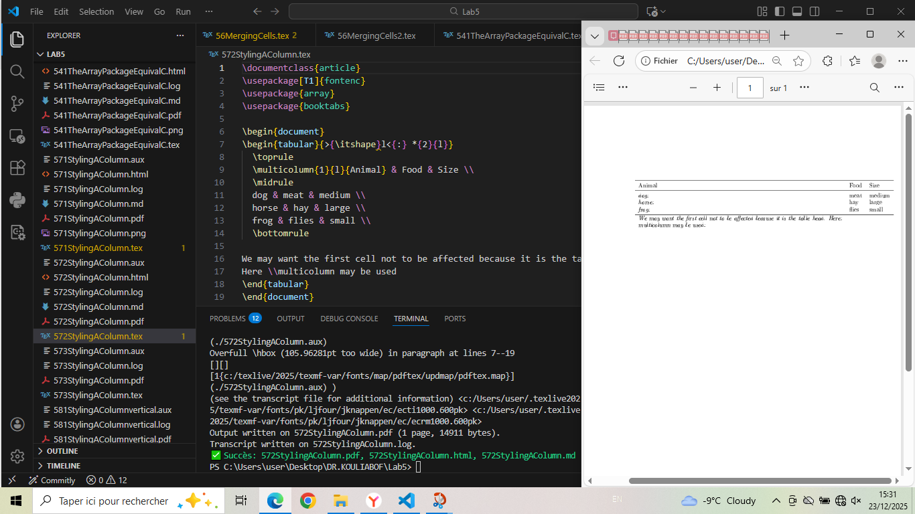

# 573StylingAColumn - @... Syntax

\documentclass{article}  
\usepackage[T1]{fontenc}  
\usepackage{array}  
\begin{document}  
\begin{tabular}{l@{ : }l@{\hspace{2cm}}l}  
 Animal & Food & Size \\  
 dog & meat & medium \\  
 horse & hay & large \\  
 frog & flies & small \\  
  
section{Commentary:}  
This preamble token does something pretty similar. The difference is, that it adds  
its argument in center of the space between two columns.   
\end{tabular}  
\end{document}

## Generated figure

Table with custom column separators.

## Screenshot

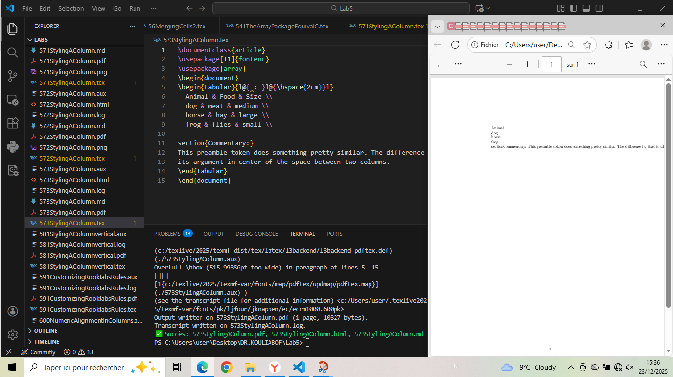

# 581StylingAColumnvertical - Vertical Rules

\documentclass{article}  
\usepackage[T1]{fontenc}  
\usepackage{array}  
  
\begin{document}  
\begin{tabular}{l|ll}  
 Animal & Food & Size \\[2pt]  
 dog & meat & medium \\  
 horse & hay & large \\  
 frog & flies & small \\  
\end{tabular}  
\section{Intepretation}: We might notice that the behavior of this implementation is pretty similar to \\{decl}; it adds the  
vertical rule between two columns leaving the padding as it is.  
\end{document}

## Generated figure

Table with vertical rule and row spacing.

## Screenshot

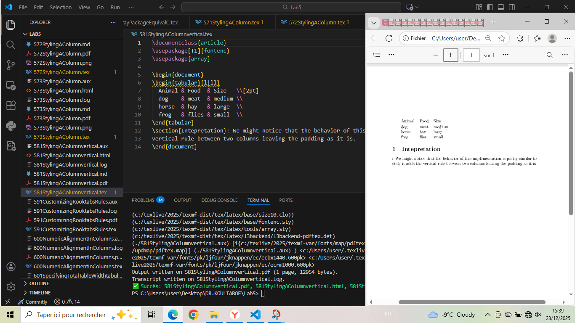

# 591CustomizingRooktabsRules - Custom Rule Thickness

\documentclass{article}  
\usepackage[T1]{fontenc}  
\usepackage{array}  
\usepackage{booktabs}  
  
\begin{document}  
  
 \begin{tabular}{@{} lll@{}} \toprule[2pt]  
 Animal & Food & Size \\ \midrule[1pt]  
 dog & meat & medium \\  
 \cmidrule[0.5pt](r{1pt}l{1cm}){1-2}  
 horse & hay & large \\  
 frog & flies & small \\ \bottomrule[2pt]  
\end{tabular}  
\end{document}

## Generated figure

Table with customized rule thickness.

## Screenshot

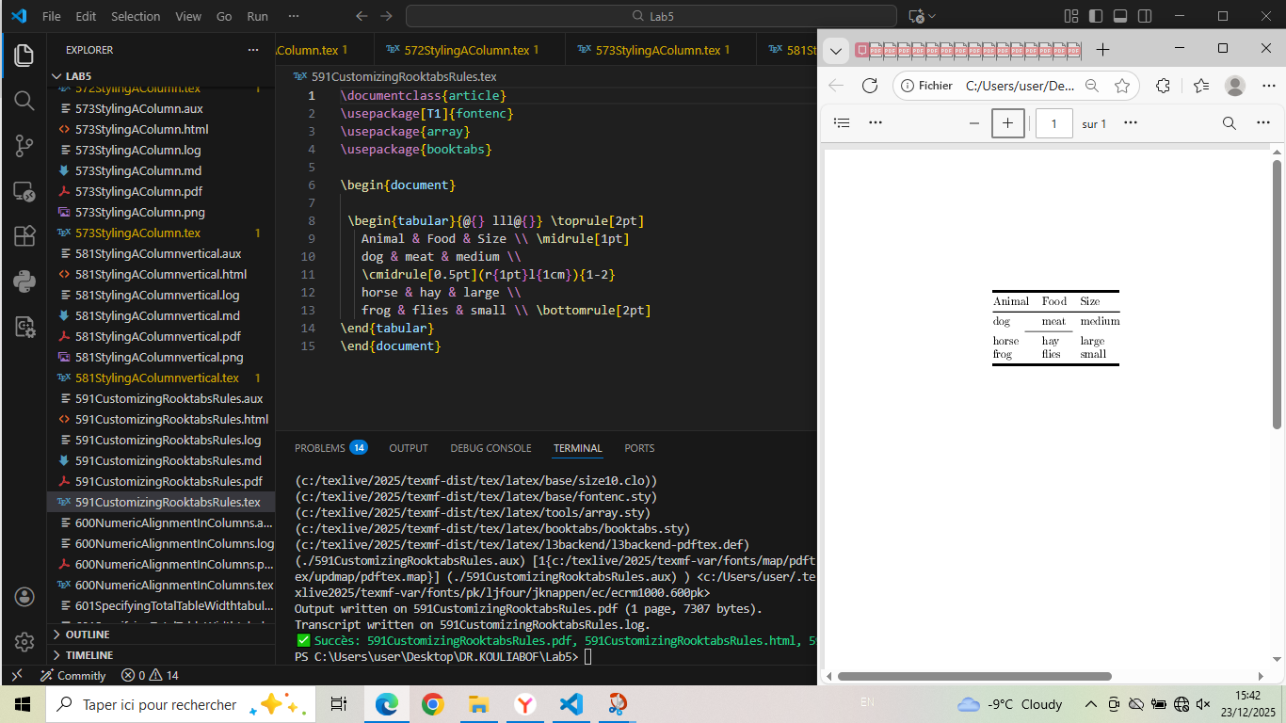

# 600NumericAlignmentInColumns - Numeric Alignment with siunitx

\documentclass{article}  
\usepackage[T1]{fontenc}  
\usepackage{booktabs}  
\usepackage{siunitx}  
\begin{document}  
\begin{tabular}{SS}  
\toprule  
{Values} & {More Values} \\  
\midrule  
1 & 2.3456 \\  
1.2 & 34.2345 \\  
-2.3 & 90.473 \\  
40 & 5642.5 \\  
5.3 & 1.2e3 \\  
0.2 & 1e4 \\  
\bottomrule  
\end{tabular}  
\section{Commentary and Interpretation}  
Here, before succeed to run the file,  
i was oblige to install the paquets siunitx.  
\end{document}

## Generated figure

Table with numeric alignment using siunitx S columns.

## Screenshot

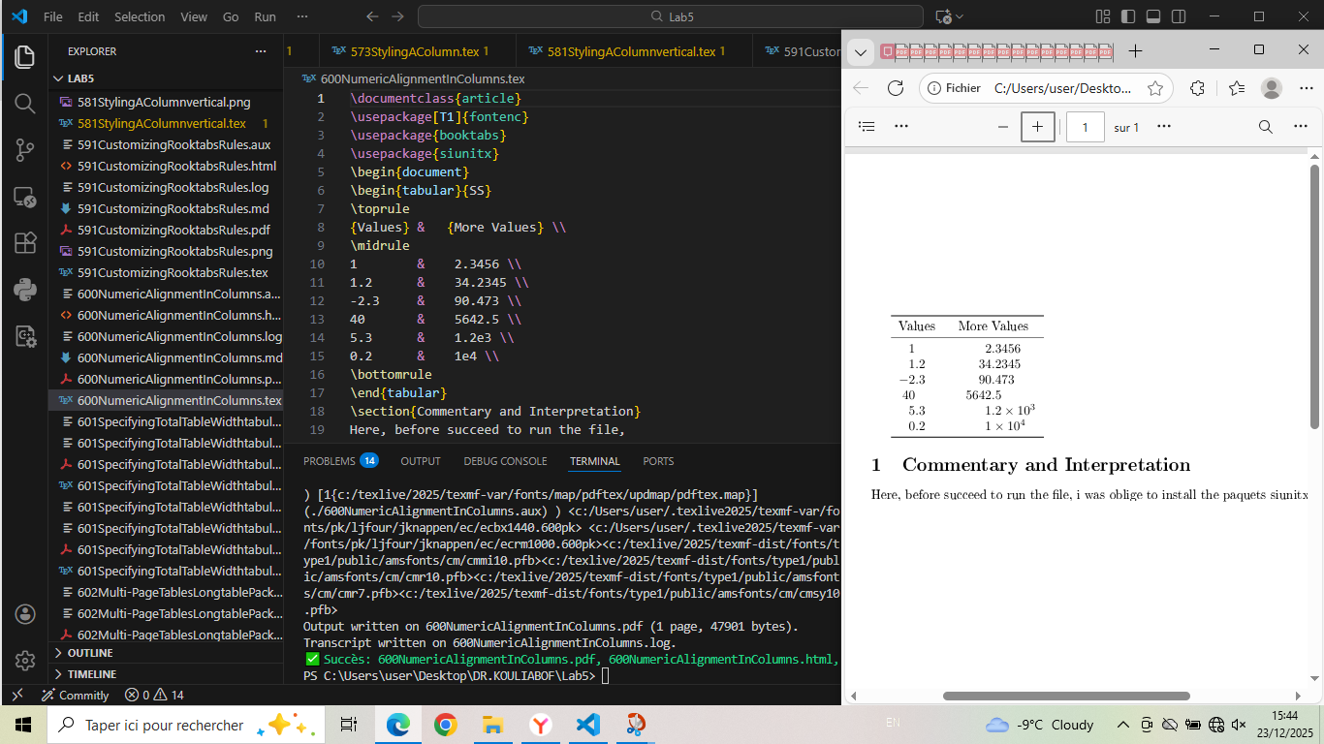

# 601SpecifyingTotalTableWidthtabularx - tabularx Environment

\documentclass{article}  
\usepackage[T1]{fontenc}  
\usepackage{tabularx}  
\begin{document}  
  
The tabularx environment, provided by the package of the same name, has a  
similar syntax to tabular* but instead of adjusting the inter-column space, adjusts  
the widths of columns specified by a new column type, X. This is equivalent to a  
specification of p{...} for an automatically determined width.  
  
\begin{center}  
\begin{tabular}{lp{2cm}}  
\hline  
A & B B B B B B B B B B B B B B B B B B B B B B B B\\  
C & D D D D D D D\\  
\hline  
\end{tabular}  
\end{center}  
\begin{center}  
\begin{tabularx}{.5\textwidth}{lX}  
\hline  
A & B B B B B B B B B B B B B B B B B B B B B B B B\\  
C & D D D D D D D\\  
\hline  
\end{tabularx}  
  
\end{center}  
\begin{center}  
\begin{tabularx}{\textwidth}{lX}  
\hline  
A & B B B B B B B B B B B B B B B B B B B B B B B B\\  
C & D D D D D D D\\  
\hline  
\end{tabularx}  
\end{center}  
\section{Commentary and intepretation}   
 The tabularx environment, provided by the package of the same name, has a  
similar syntax to tabular* but instead of adjusting the inter-column space, adjusts  
the widths of columns specified by a new column type, X. This is equivalent to a  
specification of p{...} for an automatically determined width.  
\section{Conlusion}  
Unlike the other forms discussed in these lessons, tabularx needs to typeset the  
table several times with trial widths to determine the final setting. This means  
that there are several restrictions on the use of the environment; We can see the package  
documentation to learn about its.  
\end{document}

## Generated figure

Tables demonstrating tabularx with X columns.

## Screenshot

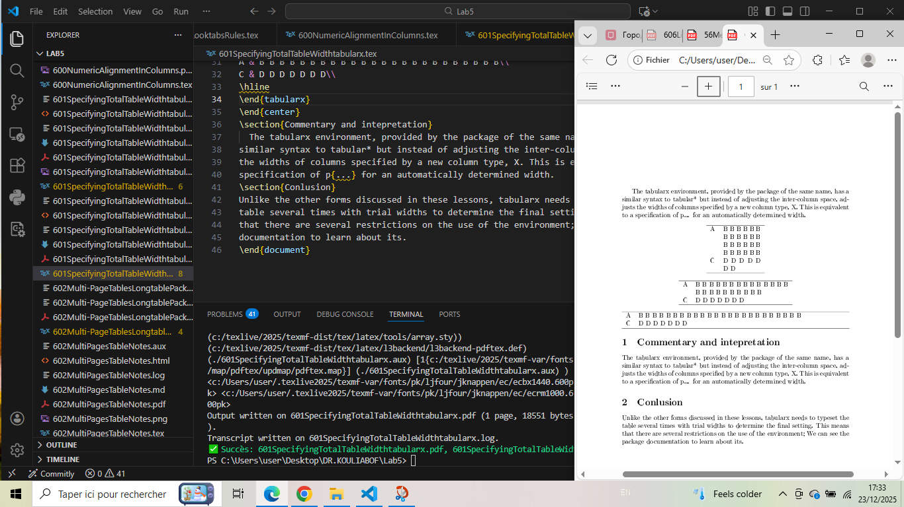

# 602MultiPagesTableNotes - Table with Notes

\documentclass{article}  
\usepackage[T1]{fontenc}  
\usepackage{array}  
\usepackage{threeparttable}  
\begin{document}  
  
\begin{table}  
\begin{threeparttable}  
 \caption{An Example}  
 \begin{tabular}{ll}  
 An entry & 42\tnote{1}\\  
 Another entry & 24\tnote{2}\\  
 \end{tabular}  
 \begin{tablenotes}  
 \item [1] the first note.  
 \item [2] the second note.  
 \end{tablenotes}  
\end{threeparttable}  
\end{table}  
\end{document}

## Generated figure

Table with footnotes using threeparttable.

## Screenshot

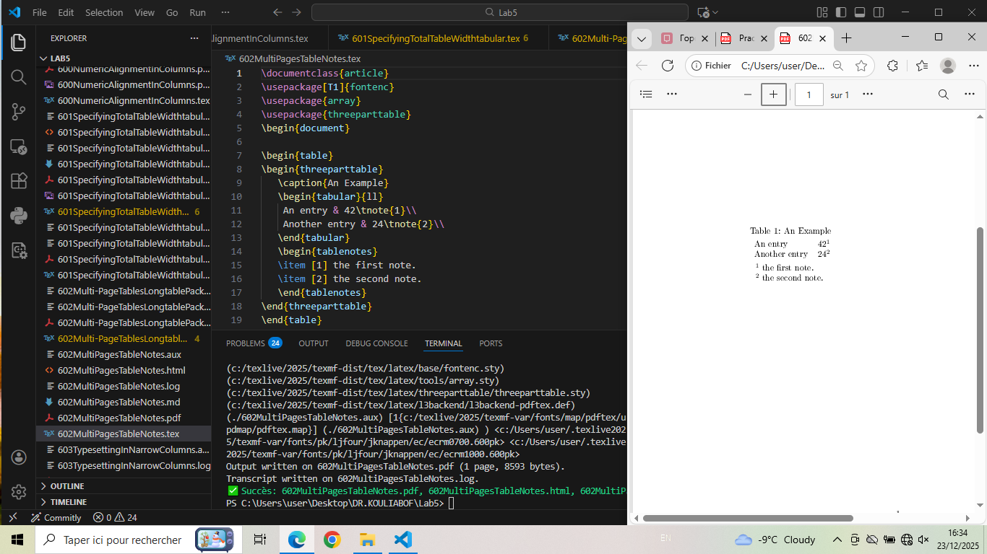

# 602Multi-PageTablesLongtablePackage - Longtable Example

\documentclass{article}  
\usepackage[paperheight=8cm,paperwidth=8cm]{geometry}  
\usepackage{array}  
\usepackage{longtable}  
\begin{document}  
  
\begin{longtable}{cc}  
\caption{A Long Table} \\  
Left Side & Right Side\\  
\hline  
\endfirsthead  
  
\multicolumn{2}{c}{\tablename\ \thetable\ (continued)} \\  
Left Side & Right Side\\  
\hline  
\endhead  
  
\hline  
\endfoot  
\hline  
\endlastfoot  
  
aa & bb\\  
Entry & b\\  
a & b\\  
a & b\\  
a & b\\  
a & b\\  
a & b\\  
a & bbb\\  
a & b\\  
a & b\\  
a & b\\  
a & b\\  
a & b\\  
a & b\\  
a & b b b b b b\\  
a & b b b b b\\  
a & b b\\  
A Wider Entry & b\\  
\end{longtable}  
  
\end{document}

## Generated figure

Multi-page table using longtable package.

## Screenshot

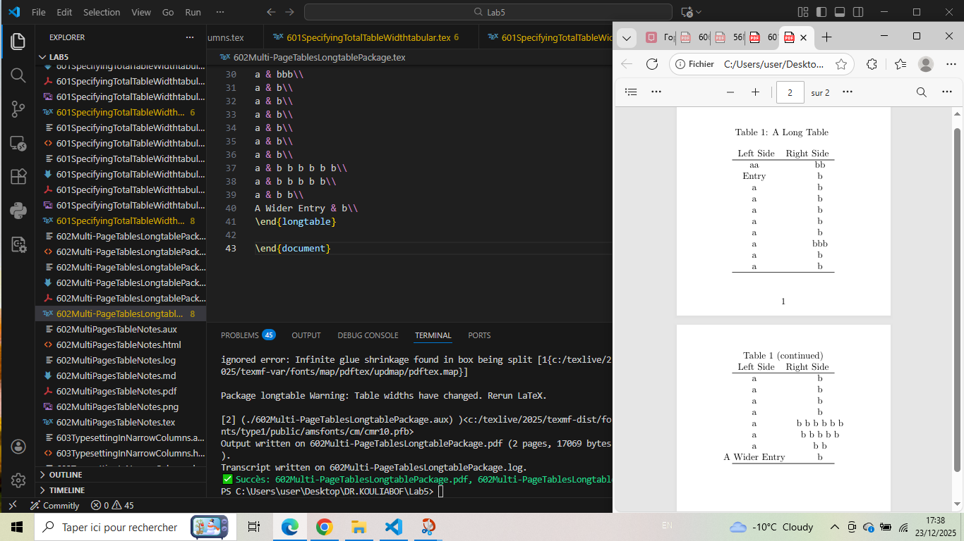

# 603TypesettingInNarrowColumns - Text in Narrow Columns

\documentclass[a4paper]{article}  
\usepackage[T1]{fontenc}  
\usepackage{array}  
\usepackage{ragged2e}  
\begin{document}  
  
\begin{table}  
   
\begin{tabular}[t]{lp{3cm}}  
One & A long text set in a narrow paragraph, with some more  
 example text.\\  
Two & A different long text set in a narrow paragraph, with  
 some more hard to hyphenate words.  
\end{tabular}%  
\begin{tabular}[t]{l>{\raggedright\arraybackslash}p{3cm}}  
One & A long text set in a narrow paragraph, with some more  
 example text.\\  
Two & A different long text set in a narrow paragraph, with  
 some more hard to hyphenate words.  
\end{tabular}%  
\begin{tabular}[t]{l>{\RaggedRight}p{3cm}}  
One & A long text set in a narrow paragraph, with some more  
 example text.\\  
Two & A different long text set in a narrow paragraph, with  
 some more hard to hyphenate words.  
\end{tabular}  
\footnotesize  
\begin{tabular}[t]{lp{3cm}}  
One & A long text set in a narrow paragraph, with some more  
 example text.\\  
Two & A different long text set in a narrow paragraph, with  
 some more hard to hyphenate words.  
\end{tabular}  
  
\end{table}  
  
\end{document}

## Generated figure

Tables with text in narrow columns and different text alignment.

## Screenshot

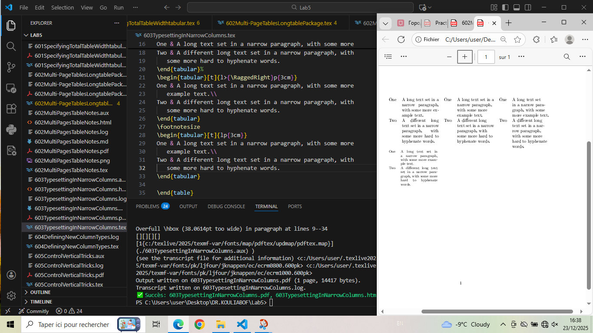

# 605ControlVerticalTricks - Vertical Alignment Control

\documentclass{article}  
\usepackage[T1]{fontenc}  
\usepackage{array}  
\usepackage{booktabs}  
  
\begin{document}  
\begin{tabular}{lcc}  
 \toprule  
 Test & \begin{tabular}[b]{@{}c@{}}A\\a\end{tabular} &  
 \begin{tabular}[t]{@{}c@{}}B\\b\end{tabular} \\  
 \midrule  
 Content & is & here \\  
 Content & is & here \\  
 Content & is & here \\  
 \bottomrule  
\end{tabular}  
We Note that We can control vertical alignment by an optional argument to the tabular;  
it supports the usage of t, c, or b for top, centered,or bottom aligned respectively.  
  
\end{document}

## Generated figure

Table with nested tables demonstrating vertical alignment.

## Screenshot

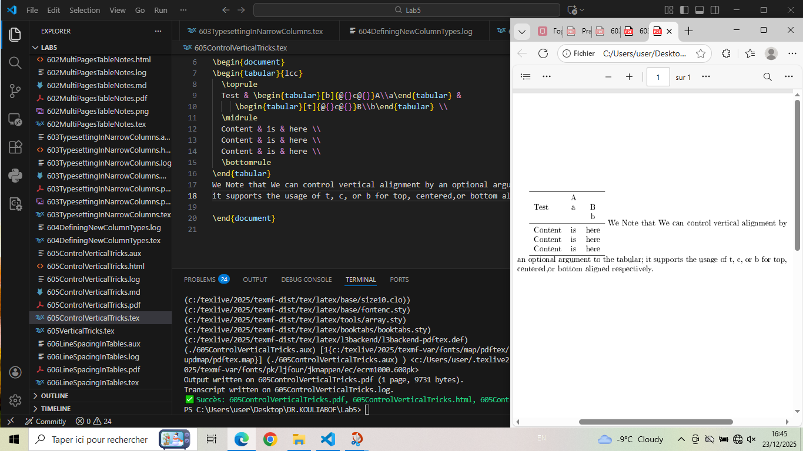

# 605VerticalTricks - Nested Tables

\documentclass{article}  
\usepackage[T1]{fontenc}  
\usepackage{array}  
\usepackage{booktabs}  
  
\begin{document}  
\begin{tabular}{lcc}  
 \toprule  
 Test & \begin{tabular}{@{}c@{}}A\\a\end{tabular} &  
 \begin{tabular}{@{}c@{}}B\\b\end{tabular} \\  
 \midrule  
 Content & is & here \\  
 Content & is & here \\  
 Content & is & here \\  
 \bottomrule  
\end{tabular}  
\end{document}

## Generated figure

Table with centered nested tables.

## Screenshot

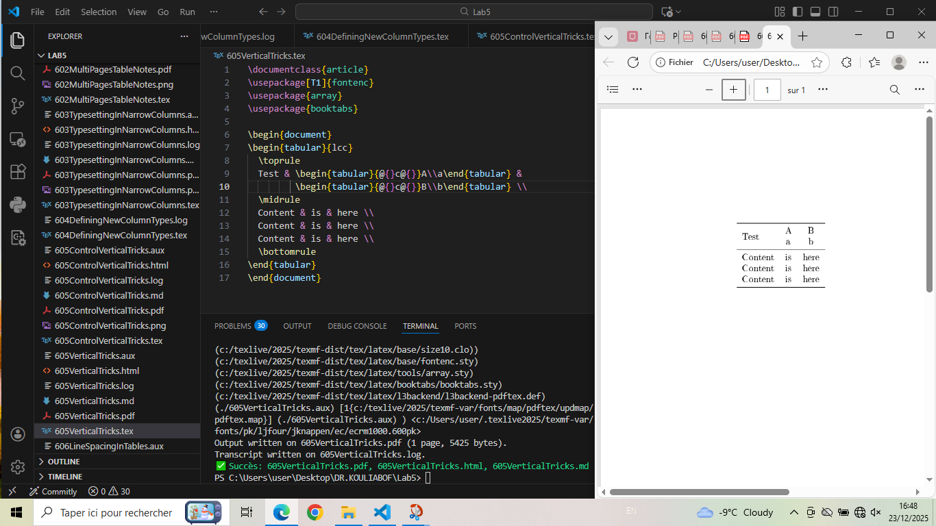

# 606LineSpacingInTables - Line Spacing Control

\documentclass[a4paper]{article}  
\usepackage[T1]{fontenc}  
\usepackage{array}  
\begin{document}  
  
\begin{center}  
\begin{tabular}{cc}  
\hline  
Square& $x^2$\\  
\hline  
Cube& $x^3$\\  
\hline  
\end{tabular}  
\end{center}  
  
\begin{center}  
\setlength\extrarowheight{2pt}  
\begin{tabular}{cc}  
\hline  
Square& $x^2$\\  
\hline  
Cube& $x^3$\\  
\hline  
\end{tabular}  
\end{center}  
\end{document}

## Generated figure

Tables demonstrating line spacing control with extrarowheight.

## Screenshot

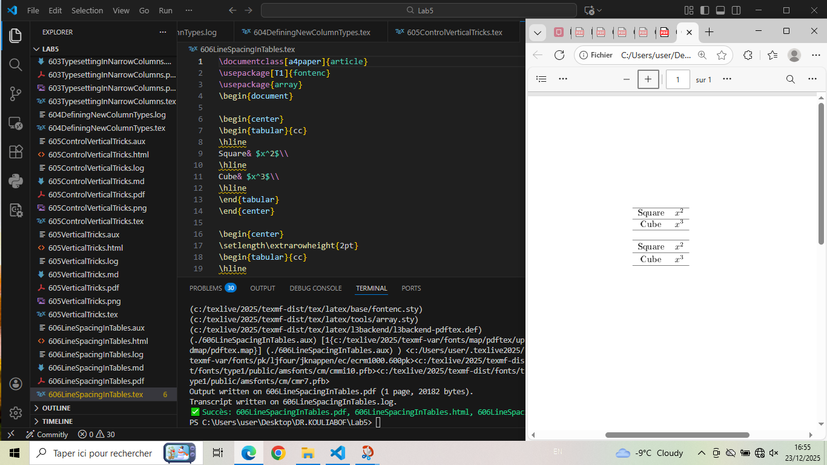

# 601SpecifyingTotalTableWidthtabular - Fixed Width Tables

\documentclass{article}  
\usepackage[T1]{fontenc}  
\usepackage{array}  
\begin{document}  
  
\begin{center}  
\begin{tabular}{cc}  
\hline  
A & B\\  
C & D\\  
\hline  
\end{tabular}  
\end{center}  
  
\begin{center}  
\begin{tabular*}{.5\textwidth}{@{\extracolsep{\fill}}cc@{}}  
\hline  
A & B\\  
C & D\\  
\hline  
\end{tabular*}  
  
\end{center}  
\begin{center}  
\begin{tabular*}{\textwidth}{@{\extracolsep{\fill}}cc@{}}  
\hline  
A & B\\  
C & D\\  
\hline  
\end{tabular*}  
\end{center}  
\ The tabular* environment takes an additional width argument that specifies  
the total width of the table. Stretchy space must be added to the table   
using the \verb|\extracolsep| command. This space is added between all columns from that  
point in the preamble. It is almost always used with \verb|\fill| a special space that  
stretches to be as large as necessary  
\end{document}

## Generated figure

Tables with specified total width using tabular*.

## Screenshot

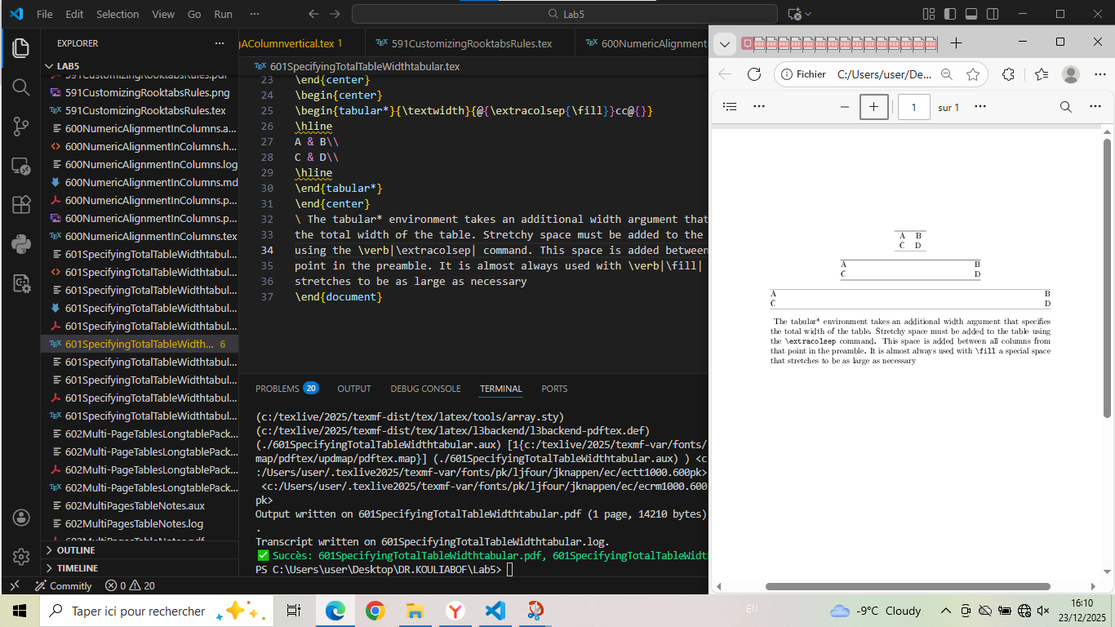

# Conclusion: Methodology for Creating Tables

After comprehensive analysis of table examples, here is the structured methodology for creating effective tables:

## 1. Essential table structure

\begin{tabular}{column specifications}  
 \toprule  
 Header1 & Header2 & Header3 \\  
 \midrule  
 Data1 & Data2 & Data3 \\  
 Data4 & Data5 & Data6 \\  
 \bottomrule  
\end{tabular}

## 2. Column type specifications

| **Type** | **Description** | **Use Case** |
| --- | --- | --- |
| l | Left-aligned column | Text data, labels |
| c | Centered column | Numbers, short text |
| r | Right-aligned column | Numbers, dates |
| p{width} | Paragraph column | Long text, descriptions |
| m{width} | Middle-aligned paragraph | Text with vertical centering |
| b{width} | Bottom-aligned paragraph | Special layouts |
| S | Numeric alignment (siunitx) | Decimal numbers, scientific notation |
| X | Automatic width (tabularx) | Flexible column widths |

## 3. Recommended workflow

**Step 1: Plan table structure**

* Determine number of columns and rows
* Choose appropriate column types
* Consider table width and alignment

**Step 2: Create basic table**

1. Set up tabular environment with column specifications
2. Add headers
3. Insert data rows

**Step 3: Enhance appearance**

* Add rules (toprule, midrule, bottomrule, cmidrule)
* Adjust column spacing (tabcolsep)
* Style columns (>, <, @)
* Add vertical spacing (addlinespace, [dim])

**Step 4: Test and refine**

* Check width and alignment
* Verify readability
* Test with different data

## 4. Advanced techniques

**Key advanced features:**

1. **Multi-column cells**: \multicolumn{n}{type}{content}

2. **Column styling**: >{\itshape}l for italic first column

3. **Custom separators**: @{ : } for colon separator

4. **Fixed width tables**: tabular* with \extracolsep{\fill}

5. **Vertical alignment**: Optional argument [t], [c], [b] to tabular

6. **Numeric formatting**: siunitx package for decimal alignment

7. **Multi-page tables**: longtable package for tables spanning pages

8. **Table notes**: threeparttable package for footnotes

## 5. Best practices

| **Practice** | **Benefit** |
| --- | --- |
| Use booktabs for rules | Professional appearance, proper spacing |
| Consistent alignment | Improved readability |
| Appropriate column widths | Balanced layout |
| Minimal vertical rules | Clean, modern look |
| Proper header styling | Clear data organization |
| Adequate spacing | Easy to read and interpret |
| Use X columns for flexibility | Automatic width adjustment |

## 6. Common issues and solutions

* **Overfull hboxes**: Adjust column widths or use tabularx
* **Poor text wrapping**: Use p{width} column type or ragged2e
* **Uneven spacing**: Adjust tabcolsep or use @ syntax
* **Vertical alignment issues**: Use m{width} or vertical position optional argument
* **Decimal misalignment**: Use siunitx S column type
* **Multi-page tables**: Use longtable instead of tabular
* **Table notes**: Use threeparttable for proper footnote placement

**Final recommendation**: Start with simple tables using basic column types, gradually incorporate advanced features as needed, and always prioritize clarity and readability. Well-designed tables effectively communicate complex data and enhance document professionalism.